**Patient Participation Group Meeting – Tuesday 16th July 2024**

**Attendees**

Joanne Mcelwee Practice Manger – JM

Dr Rachel Bloomfield GP Partner – RB

Nicola Hyde Reception Supervisor – NH

PPG Members – TB

BC

CF

GL

**Introduction**

Attending members of the Patient Participation Group and Staff introduced themselves for the benefit of those who weren't in attendance of the last meeting or were new the group.

**Minutes of the previous meeting**

The minutes of the previous meeting held on 13th March 2024 had been emailed to the attendees after the previous meeting.

**Updates and Goals from previous meeting**

JM advised the group that we are yet to advertise that the surgery is taking on new patients as decided at last meeting, with involvement of PPG, parish newsletter etc, as the practice have recently adopted a new online registration process. All practices will have to implement this from October 2024 but we have implemented it in advance. The new system allows patients to register themselves via the NHS App, NHS Online or a link on the practice website. The patient would enter their postcode and the link will then inform them which practice they could register with. This has been added to our website and we have had several patients register using this system. Patients can still come to the surgery to complete a paper form if they prefer. A member of the group wondered how many online/paper registrations we received NH will do an audit of this for the next PPG meeting.

**Agenda items and Updates**

**New phone system**

JM informed the group that the surgery had received funding for our new phone system which informs the patients where they are in the queue and if they are caller 20 or above they are offered a call back. If the patients take this option the system calls them back when they are number one in the queue. So far the surgery has received positive feedback from the patients about the new phone system. JM then shared with the meeting phone data

**Research**

RB informed the group that she is now the Research Lead and the surgery is currently involved with the following studies :-

1 – Intestinal Study. This involves 18-79-year olds. They will do a weekly report for 6-months of their bowel habits. If they develop diarrhoea they will be asked to do a sample.

2 – Diarrhoea study – similar to the above research – patients who have diarrhoea will asked if they will take part in this research study and provide a stool sample.

3 – UTI's – Women only. This study is researching the optimum amount of time a patient should take an antibiotic for a UTI. They will be asked about their symptoms and the time taken for them to be better.

4 – Parkinson's disease research

5 – Lung disease research

6 – Virology respiratory research – this study has been running for nearly a year. It is looking into respiratory conditions such as covid. This involves a nasal swab

RB informed the meeting that all these research studies are on the website.

**Flu/covid and RSV vaccine**

JM informed the group about the winter vaccine program. No exact dates have been set yet for the flu campaign but the covid vaccine does not start until the 1st October.

RSV is a new vaccine that will be given to patients aged between 75-79 and expectant mothers it protects against viral bronchiolitis

**Patient Satisfaction Survey**

JM presented to the meeting the Patient Satisfaction Survey from June 2024:-

* **Very Good - 465 responses**
* **Good - 52 responses**
* **Neither Good Nor Poor  - 7 responses**
* **Poor - 3 responses**
* **Very Poor - 2 responses**

JM also presented to the group NHS Survey for the Practice:

JM had been on a course where she was informed that the NHS Survey was probably a truer picture as this survey is a random survey. whereas Patient Satisfaction Survey is only sent to patients who have had an appointment with one of the clinicians.

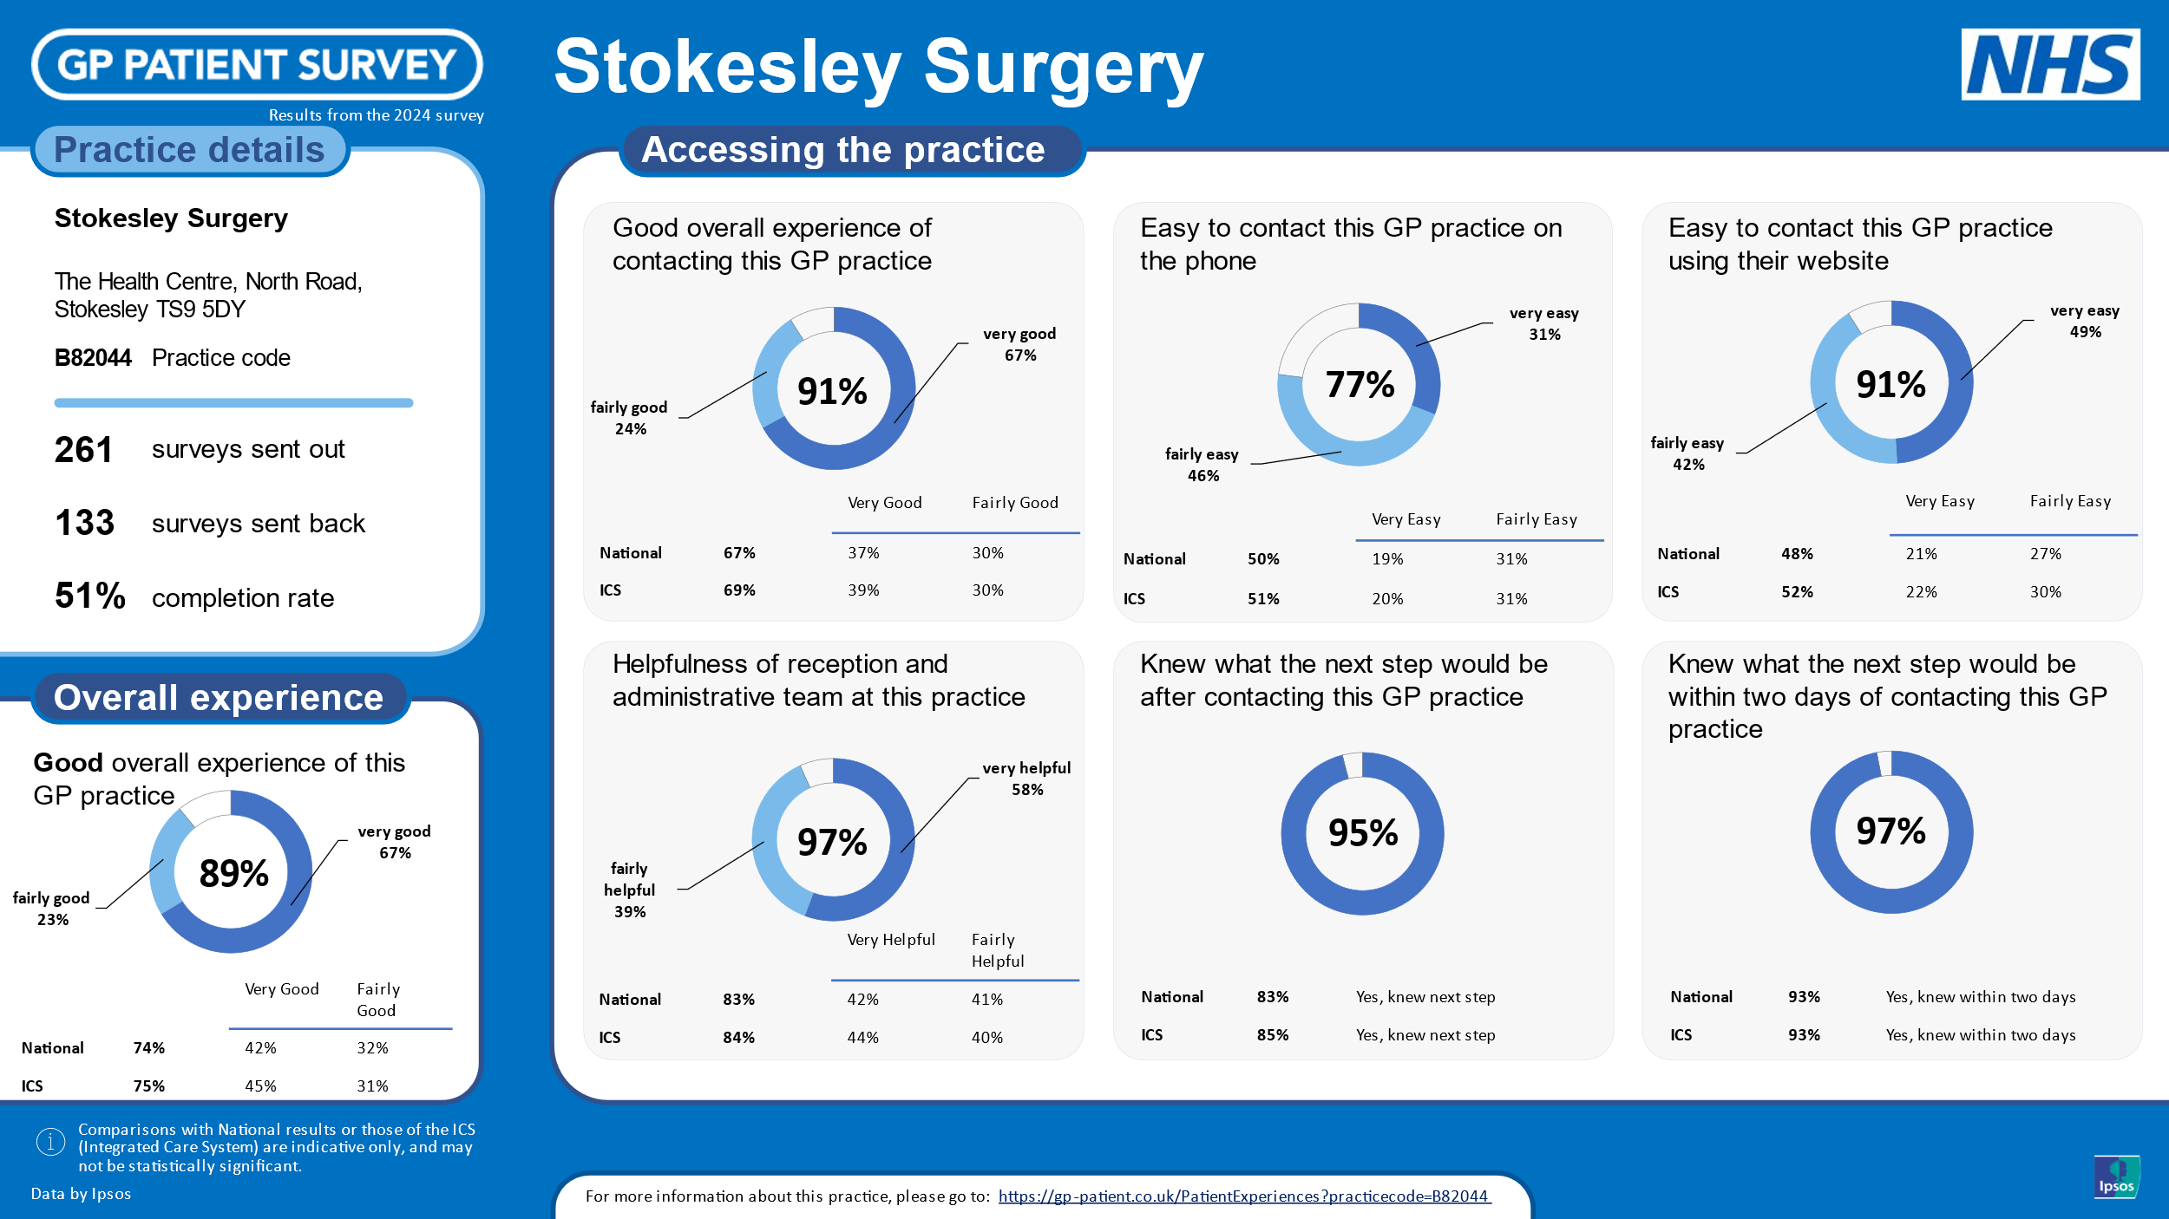

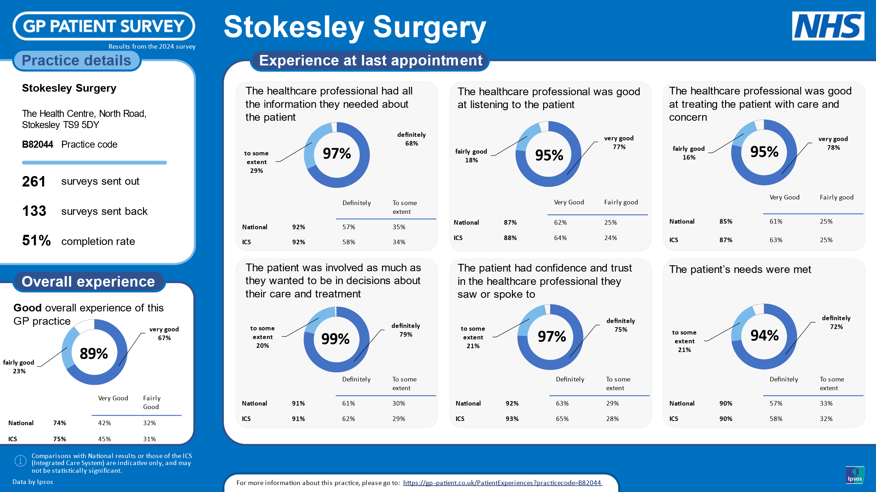

**Aims of the PPG**

CF raised a question about the aims of the PPG group he was particularly interested in the following:-

* Population at large and the Practice as a whole
* Health Centre Constitution, Governance and Management
* Funding
* NHS relationships
* Suppliers and the interface between primary and secondary care

There was a discussion held regarding the above and the complexity surrounding each of these issues. It was decided that one of the subjects would be discussed at the beginning of each PPG meeting. When we were discussing the aims of Health Centre it was queried whether PPG members could be involved in CCG type meetings. JM said that she had been to meetings in the past where this had happened and is looking into how the PPG can get involved if they would like to.

It was decided that the topic we shall cover at the next meeting will be Health Centre management structure, constitution and governance.

**Any Other Business**

TB asked about removal of ear wax in the surgery. JM explained that this was stopped during covid and was not recommissioned for GP surgeries to do. Patients can be referred to the hospital. Members asked about the current wait time to be seen. NH checked after the meeting and the next available appointment for James Cook University Hospital is Aug 2024, Friarage Hospital is December 2024

The Members discussed patient's who DNA appointments and what can be done to rectify this. We up date the TV screens, website and Facebook regarding how many DNA's we have a month. NH mentioned that she does put it on Facebook if we have a lot of DNA's on a particular day. The surgery used to contact patients who were regular non-attenders, JM mentioned this is maybe something we should do again. TB had devised a messaged that could be sent from the PPG member on behalf of the Surgery to all the patients regarding DNA'd appointments and the importance of cancelling appointments. It was agreed that this would be done and it would also added to the website and TV screens.

NH reminded the members that they can email her anytime with any agenda suggestions

Date of next meeting October 2024 day to be confirmed.